**ICCT COLLEGE FOUNDATION, INC**

**CAINTA MAIN CAMPUS**

**V.V SOLIVEN AVE II, CAINTA RIZAL**



**FINAL PROJECT IN ITCOMSO8**

**Section:N15**

**Date & Time: T-TH-S / 1-2Pm**

**Submitted by:**

**Matthew Bisnar**

**Jayvil Rosaupan**

**Submitted to:**

**Mr.Lumar Tipudan**

**HOME PAGE (INDEX.html)**

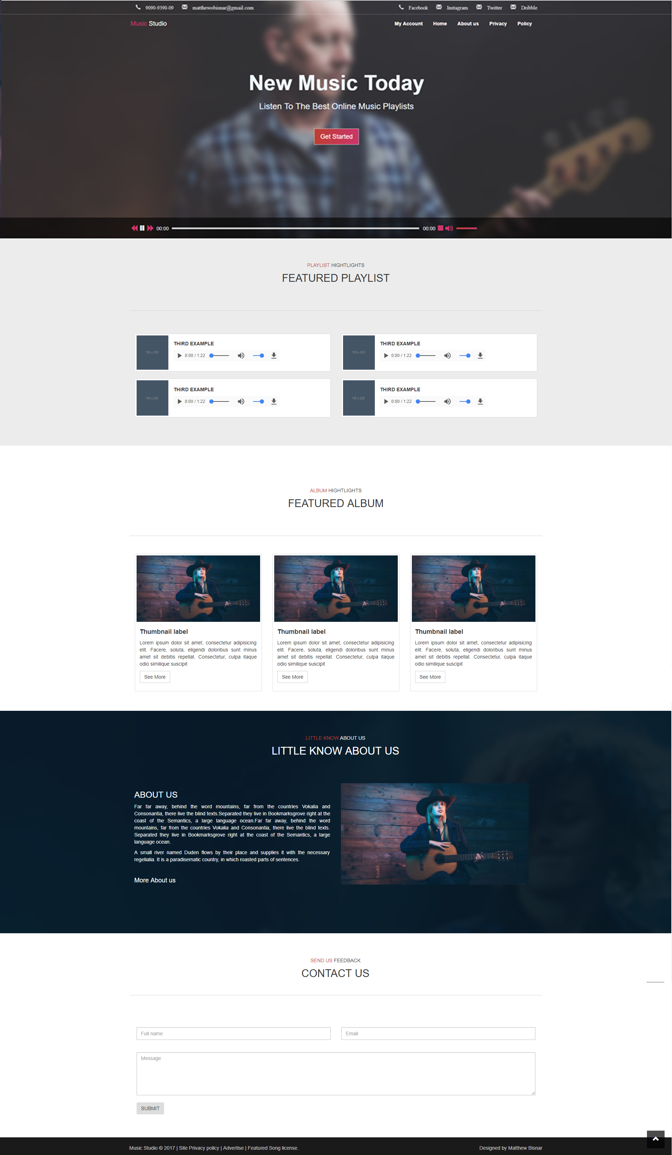

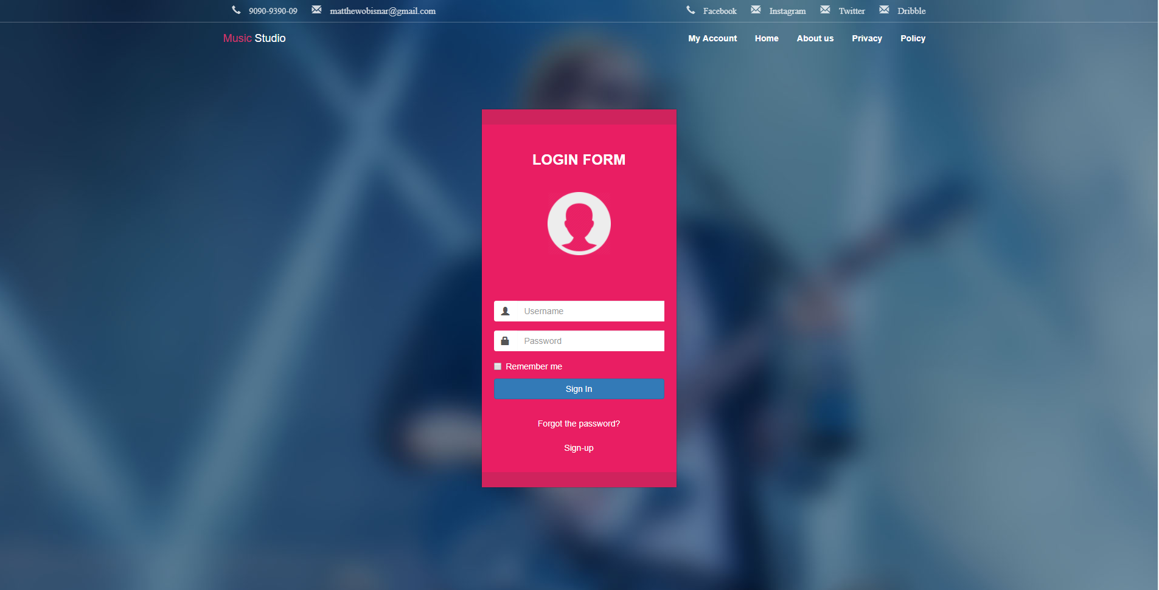**LOGIN FORM (SIGN IN.html)**

**SIGN UP FORM (SIGN UP.html)**

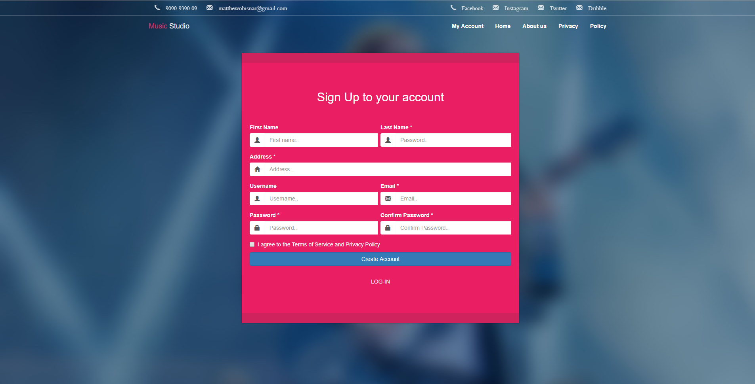

**PLAYLIST (PLAYLIST.html)**

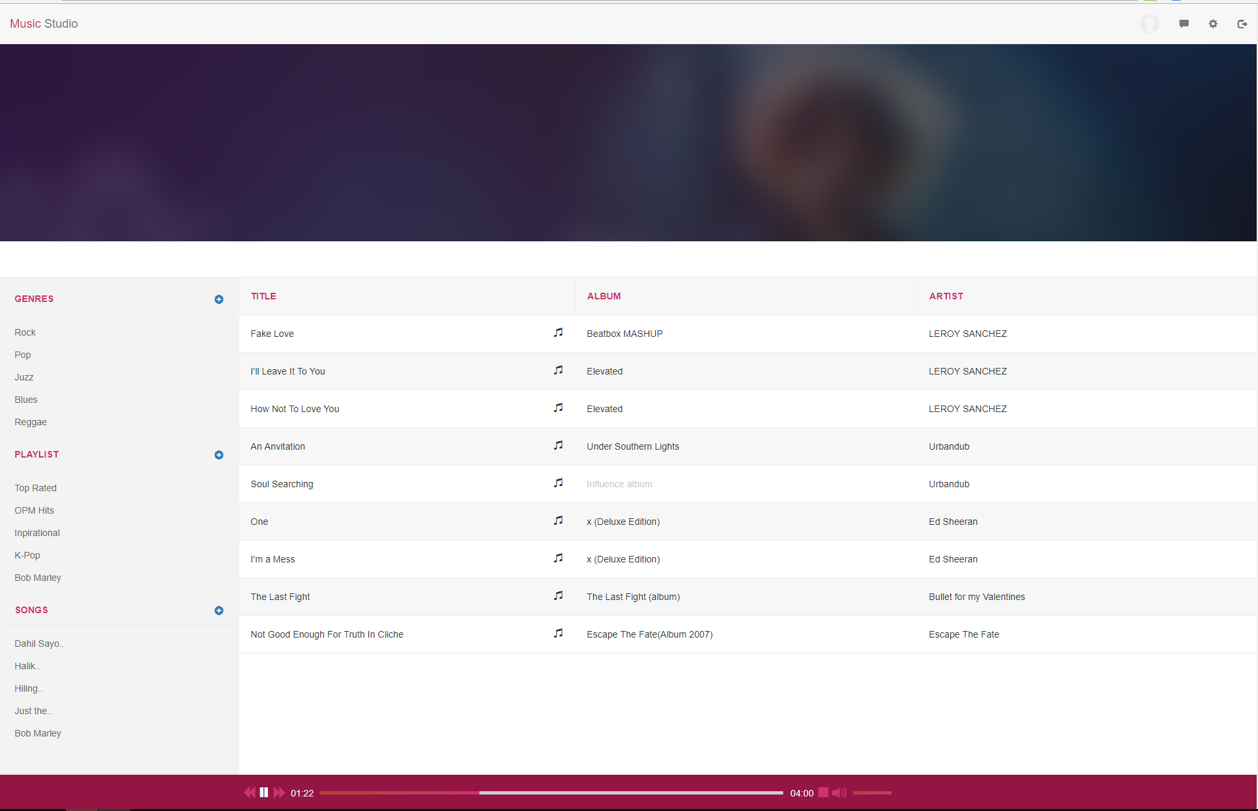

**ABOUT US (ABOUTUS.html)**

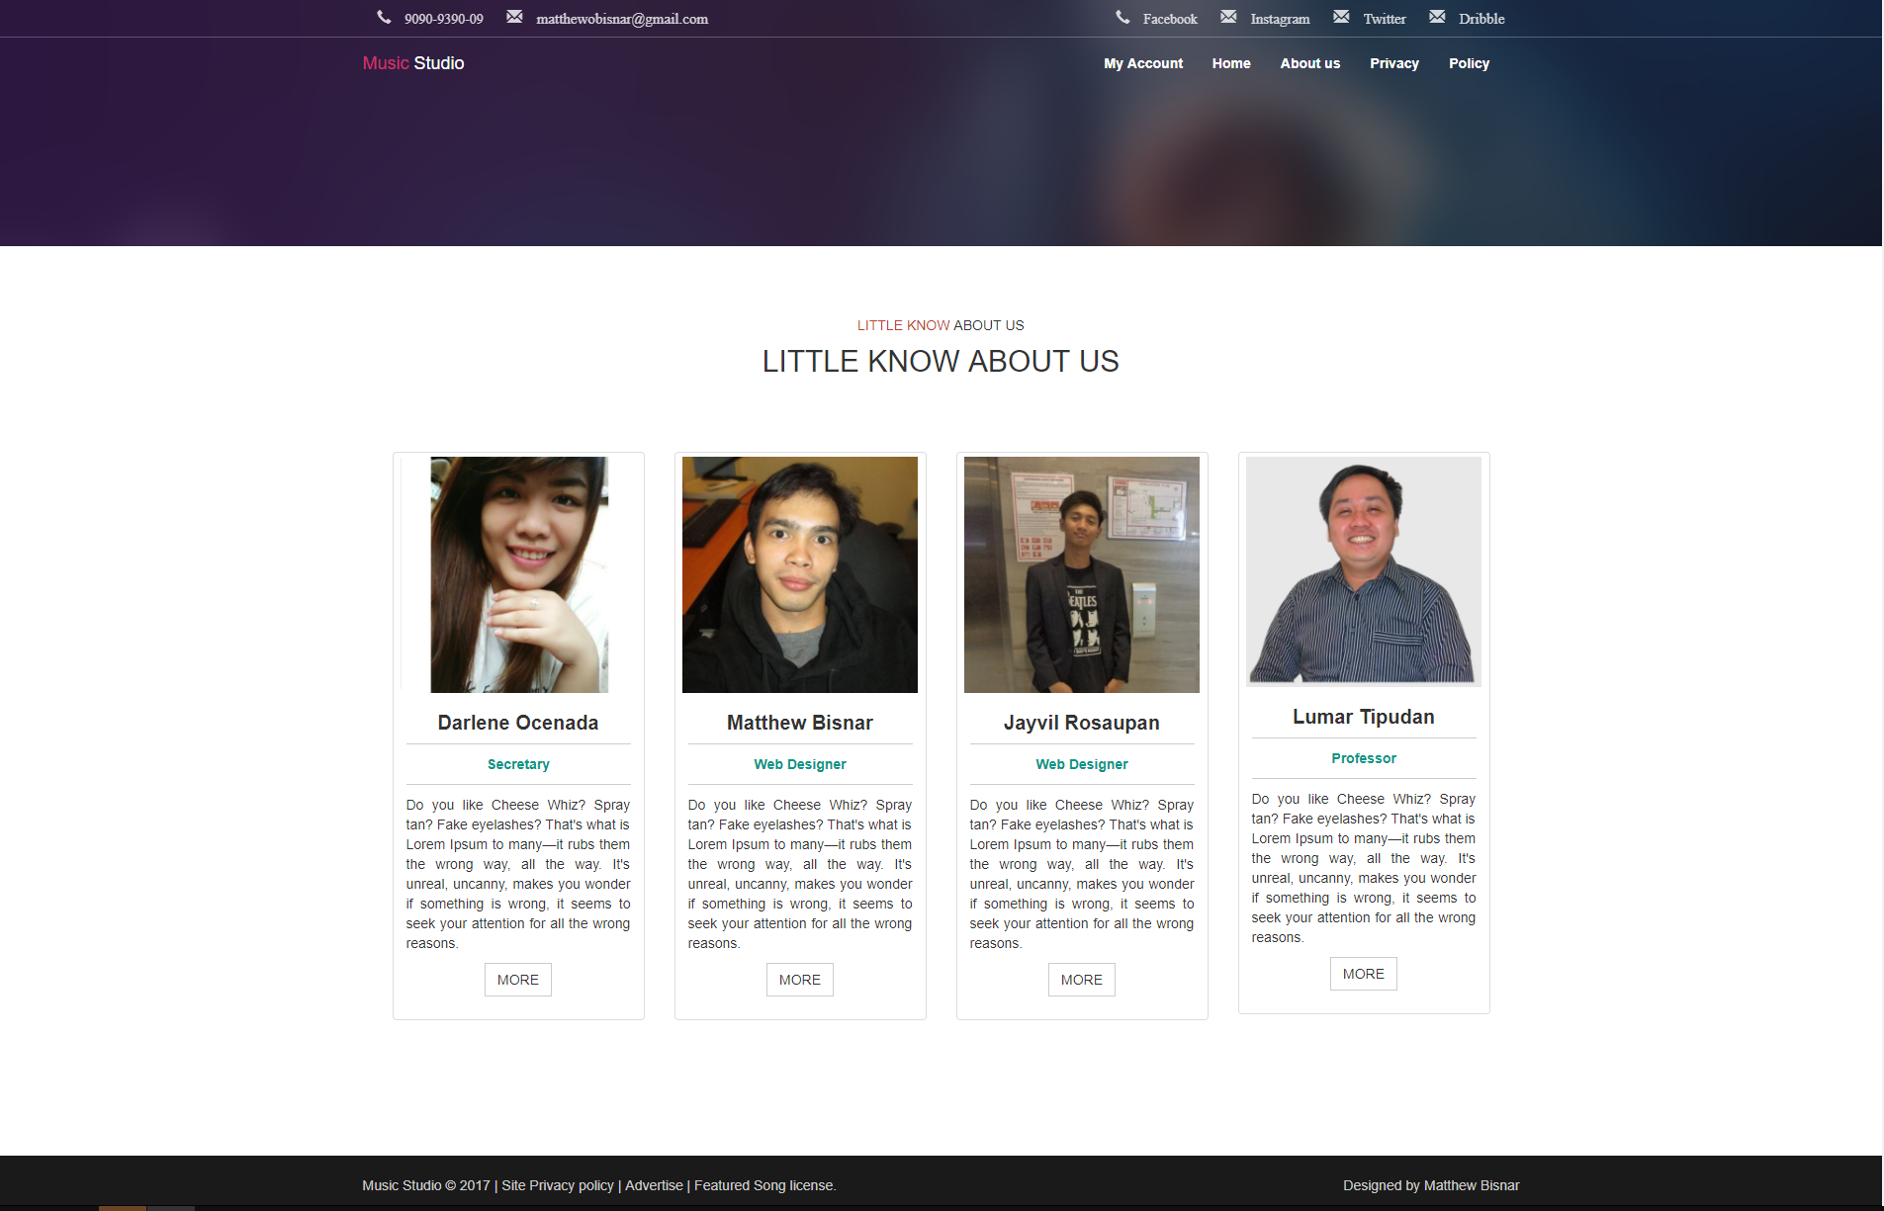

**Development Process( No. of Days)**

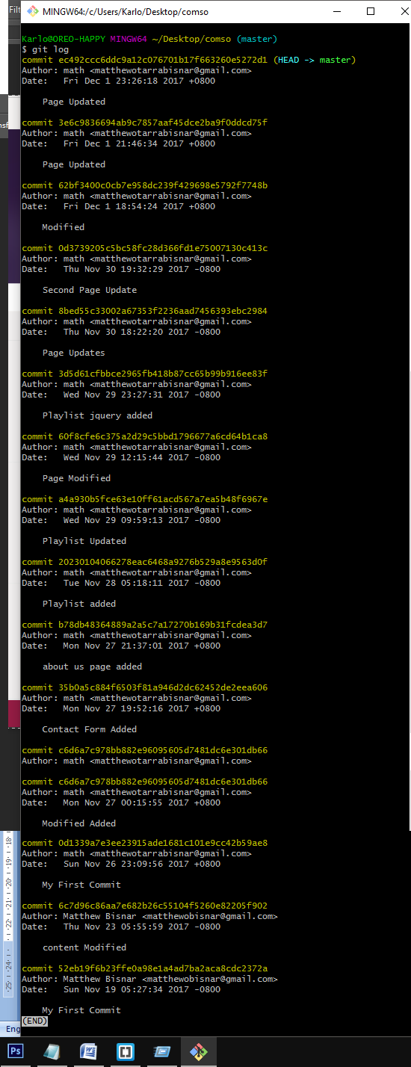

**JS SOURCE CODE (index.js)**

**/\***

**Javascript , Jquery Functionality**

**Fullpage Interaction..**

**Written by Matthew Bisnar And Jayvil Legaspi Rosaupan.**

**\*/**

**$(window).on('load', function(){**

**// Audio Source.........................................**

**var audioSource = document.getElementById('audioSource');**

**});**

**$(document).ready(function(){**

**// ========== Dynamic Height Size Header ==========**

**dynamicHeightSize();**

**$(window).on('resize', function (){**

**dynamicHeightSize();**

**});**

**function dynamicHeightSize () {**

**var dynamicHeight = $(window).height();**

**$('.headerWrapper').height(dynamicHeight);**

**}**

**// ========== End Dynamic Height Size Header ======**

**// =============== Alert Notification ==============**

**var msg = "Opps! Sorry.. No Backend Functionality.. But try to submit me :-)..";**

**// btns.........**

**alertDetails($('.btn-submit'), msg);**

**alertDetails($('.forward'), "Forward");**

**alertDetails($('.stopBtn'), "Stop");**

**alertDetails($('.backward'), "Backward");**

**alertDetails($('.audioControl'), "Volume");**

**function alertDetails (el, message,) {**

**$(el).hover(function(){**

**$(this).attr({**

**'title': message,**

**'data-toggle' : 'tooltip',**

**'data-placement' : 'left'**

**}).tooltip('show');**

**}, function() {**

**$(this).removeAttr('title').tooltip('hide');**

**});**

**}**

**// ============== End Alert Notification ============**

**// ============== scrollFix Navigation ====================**

**$(window).on('scroll', function () {**

**if ($(window).scrollTop() > $('.mainContent').offset().top) {**

**$('.navbar').addClass('navbar-fixed-top');**

**}**

**if ($(window).scrollTop() > $('.sectionWrapper').offset().top - 15) {**

**$('.navbar').removeClass('navbar-custom').addClass('navbar-inverse');**

**} else {**

**$('.navbar').addClass('navbar-custom').removeClass('navbar-inverse');**

**}**

**if ($(window).scrollTop() < $('.mainContent').offset().top) {**

**if ($('.navbar').hasClass('navbar-fixed-top')) {**

**$('.navbar').removeClass('navbar-fixed-top');**

**}**

**}**

**});**

**// =============== End ScrollFix Navigation ==================**

**// ================ Manipulating Audio API ===================**

**audioSource.src = "audio/Ed%20Sheeran%20-%20Im%20a%20Mess%20(OFFICIAL%20AUDIO).mp3";**

**// Toggle Boolean............................**

**var focusout = false;**

**var muteFocus = false;**

**audioSource.load();**

**if (audioSource !== undefined) {**

**// Comment me to if you want to stop autoplay..**

**audioSource.play();**

**if(audioSource.played && !audioSource.ended) {**

**$('.playPause > span').removeClass('glyphicon glyphicon-play').addClass('glyphicon glyphicon-pause white');**

**alertDetails ($('.playPause'), "Pause");**

**}**

**// this functionality doesn't support other browsers..**

**audioSource.addEventListener('ended', function(){**

**if ($('.playPause > span').hasClass('glyphicon glyphicon-pause white') ) {**

**$(this).removeClass('glyphicon glyphicon-pause white').addClass('glyphicon glyphicon-play');**

**audioSource.currentTime = 0;**

**}**

**});**

**}**

**// clickable bar........................**

**$('.timeLine').on('click', function(e) {**

**if (!audioSource.played || !audioSource.ended) {**

**var mos = e.clientX - $(this).offset().left;**

**audioSource.currentTime = mos * audioSource.duration / $(this).width();**

**$('.playHead').css("width", + mos + "px");**

**}**

**});**

**// Toggle Play and Pause.......................**

**$('.playPause > span').on('click', function() {**

**if (focusout == false) {**

**if ($(this).hasClass('glyphicon glyphicon-play')) {**

**$(this).removeClass('glyphicon glyphicon-play').addClass('glyphicon glyphicon-pause white');**

**}**

**alertDetails ($('.playPause'), "Pause");**

**audioSource.play();**

**focusout = true;**

**$('.playDuration').text(duration(audioSource.duration));**

**} else if (focusout == true ) {**

**if ($(this).hasClass('glyphicon glyphicon-pause white')) {**

**$(this).removeClass('glyphicon glyphicon-pause white').addClass('glyphicon glyphicon-play');**

**}**

**audioSource.pause();**

**focusout = false;**

**}**

**});**

**// Get the current Duration of audio..........**

**if (!audioSource.ended && audioSource.played) {**

**var currentDuration = setInterval(function(){**

**$('.currentTime').text(duration(audioSource.currentTime));**

**// Run Progress Bar.........................................**

**updateProgressBar(audioSource.currentTime, audioSource.duration);**

**}, parseInt(audioSource.currentTime));**

**} else if (audioSource.currentTime == audioSource.duration) {**

**clearInterval(currentDuration);**

**}**

**// Stop btn .................................**

**$('.stopBtn > span').on('click', function(){**

**if ($('.playPause > span').hasClass('glyphicon glyphicon-pause white')) {**

**$('.playPause > span').removeClass('glyphicon glyphicon-pause white').addClass('glyphicon glyphicon-play');**

**}**

**audioSource.pause();**

**audioSource.currentTime = 0;**

**focusout = false;**

**});**

**// Forward Play........................**

**$('.forward span').on('click', function() {**

**if (!audioSource.ended) {**

**audioSource.currentTime += 2;**

**}**

**});**

**// Backward Play.........................**

**$('.backward span').on('click', function() {**

**if (audioSource.currentTime > 0) {**

**audioSource.currentTime -= 2;**

**}**

**});**

**// Draw Playhead Progress bar....................**

**function updateProgressBar (currentT, durationT) {**

**bar = (currentT*($('.timeLine').width()))/durationT;**

**$('.playHead').css("width", + bar + "px");**

**}**

**// Display duration in Minutes and Seconds (M:S).........................**

**function duration (times) {**

**var minutes = parseInt(Math.floor(times/60));**

**var second = parseInt(Math.floor(times%60));**

**return ("0" + minutes).slice(-2) + ":" + ("0" + second).slice(-2);**

**}**

**// MANIPULATING THE VOLUME.....................**

**$('.audoLine').on('click', function (event) {**

**// Get the Current Mouse position by subtracting parent element offset(current postion value ) and current horizontal event click (event.pageX)..**

**var mousePositionX = event.pageX - $(this).offset().left;**

**var volumeX = mousePositionX - mousePositionX * 0.98;**

**//console.log((volumeX < 1 ) ? volumeX.toFixed(1) : Math.round(volumeX.toFixed(1)));**

**$('.audoLine > .Volume').css("width", + mousePositionX + "px");**

**//Simple ternary Conditions.. if greater 1.0.. then remove decimals ....................**

**audioSource.volume = (volumeX < 1 ) ? volumeX.toFixed(1) : Math.round(volumeX.toFixed(1));**

**});**

**// Mute THE Volume.....................**

**$('.mutedVol').on('click', function(){**

**if(muteFocus == false) {**

**$(this).removeClass('glyphicon glyphicon-volume-up').addClass('glyphicon glyphicon-volume-off');**

**$('.audoLine > .Volume').css("width", + 0 + "px");**

**muteFocus = true;**

**audioSource.volume = 0.00;**

**} else {**

**$(this).removeClass('glyphicon glyphicon-volume-off').addClass('glyphicon glyphicon-volume-up');**

**$('.audoLine > .Volume').css("width", + $('.audoLine').width() + "px");**

**muteFocus = false;**

**audioSource.volume = 1;**

**}**

**});**

**// ====================== AUDIO VISUALIZER WITH HTML5 CANVAS AND AUDIO WEB API ===========================**

**// SOURCE: Info in setting up Visualizer - https://developer.mozilla.org/en-US/docs/Web/API/Web_Audio_API**

**// SOURCE: CANVAS API - https://developer.mozilla.org/en-US/docs/Web/API/Canvas_API**

**// Declare Audio API object Instance in order to use..**

**var audioContext = new AudioContext();**

**// Connect to audio HTML source <audio>**

**var src = audioContext.createMediaElementSource(audioSource);**

**// create Anaylizer..**

**var analyser = audioContext.createAnalyser();**

**// audio source connect analyzer and its destination..**

**src.connect(analyser);**

**analyser.connect(audioContext.destination);**

**analyser.fftSize = 256; // optional...**

**// Create Draw Environment (Canvas) and 2d CTX;**

**// Unfortunately, I Can't use jquery Selectors to get the Id of canvas :-(.. so stick with old convention..**

**var canvasAPI = document.getElementById('audioAPIVisualizer');**

**var canvasContext = canvasAPI.getContext('2d');**

**//set up canvas width relative to container class..**

**canvasAPI.width = $('.container').width();**

**// add its property to array..**

**var dataArray = new Uint8Array(analyser.frequencyBinCount);**

**// setting up buffer get ratio width and height..**

**var barWidth = (canvasAPI.width/analyser.frequencyBinCount) * 0.9;**

**var barHeight;**

**var widthDistance = 0;**

**// render animation function...**

**function render() {**

**widthDistance = 0;**

**analyser.getByteFrequencyData(dataArray);**

**// Clear Canvas per Buffer Draw....**

**canvasContext.clearRect(0,0,canvasAPI.width, canvasAPI.height);**

**for (var i = 0; i < analyser.frequencyBinCount; i++) {**

**barHeight = dataArray[i];**

**//set Colors... rgb**

**var r = barHeight + (25 * (i/analyser.frequencyBinCount));**

**var g = 250 * (i/analyser.frequencyBinCount);**

**var b = 50;**

**// set canvas gradient....**

**var gradient = canvasContext.createRadialGradient(0, 0, 0, 0, 50, 100);**

**// vertical gradient arrangements...**

**gradient.addColorStop(1, "rgb(" + Math.floor(r) + "," + Math.floor(g) + "," + Math.floor(b) + ")");**

**gradient.addColorStop(0, "rgb(0, 0, 0)");**

**canvasContext.fillStyle = gradient;**

**canvasContext.fillRect(widthDistance, canvasAPI.height - barHeight * .55, barWidth, barHeight);**

**widthDistance += barWidth + 2;**

**}**

**}**

**var renderInterval;**

**// CALL RENDER FUNCTION.. per audio current counting...........**

**if (audioSource.played ) {**

**renderInterval = setInterval(function() { render(); }, audioSource.currentTime);**

**} else {**

**clearInterval(renderInterval);**

**}**

**// ================ END AUDIO VISUALIZER WITH HTML5 CANVAS AND AUDIO WEB API =========================**

**// ======================== End Audio API =======================**

**// ================= Smooth Page Transitions =====================**

**$('body').fadeIn(500 ,function(){**

**var getOffset = $('.smooth-transition').offset().top;**

**$('.smooth-transition').show('slow',function(){**

**$('.smooth-transition > h1').show('slow', function(){**

**// do something..**

**})});**

**});**

**// scroll effects here...**

**$(window).on('scroll', function() {**

**const second = 980;**

**// ----- playlist Effects ------**

**AnimateCondition ($('.sectionWrapper'),$('.playlist-title'), second);**

**AnimateCondition ($('.playlist'),$('.music-playlist'), second);**

**// ---- End Playlist Effects -------**

**// ---- album Effects ---------**

**AnimateCondition ($('.albumWrapper'),$('.album-title'),second);**

**AnimateCondition ($('.album'),$('.albumList'), second);**

**// ---- End Album Effects ------**

**// ---- About us ---------------**

**AnimateCondition ($('.aboutus'),$('.about-title'), second);**

**AnimateCondition ($('.aboutContent'),$('.about-content'), second);**

**// ---- End About us -----------**

**// ---- Contact Form -----------**

**AnimateCondition ($('.contactus'), $('.contact-us-title'), 1700);**

**AnimateCondition ($('.footer'),$('.footerMenu'), 1700);**

**// ---- End Contact Form -------**

**function AnimateCondition (parentEl, childEl, time) {**

**if($(window).scrollTop() >= parentEl.offset().top/2) {**

**childEl.fadeIn('slow', function(){**

**childEl.animate({opacity: 1}, time);**

**});**

**}**

**}**

**});**

**// ================= Scroll to Top ====================**

**$(window).on('scroll',function() {**

**if ($(this).scrollTop() >= 70) {**

**$('.return-to-top').fadeIn(300);**

**} else {**

**$('.return-to-top').fadeOut(300);**

**}**

**});**

**$('.return-to-top').click(function() {**

**$('html').animate({**

**scrollTop : 0**

**}, 500);**

**});**

**// ============= End Page Transition ==================**

**// ============ Manipulating Contact Form ==========**

**var el = $('<div> Send Success </div>').attr('id','slidedown');**

**el.insertAfter('.btn-submit');**

**// Note : Fixed later $('.email-inputs > input').hasAttr('required') != false**

**$('.btn-submit').on('click', function(e){**

**if ($('.name-inputs > input').val() !== "" && $('.textarea-inputs > textarea').val() !== "") {**

**e.preventDefault();**

**setTimeout(function() {**

**$('#slidedown').slideDown("slow", function (){**

**$(this).fadeOut(3000);**

**});**

**}, 500);**

**}**

**});**

**// =============== Manipulating Contact Form ==================**

**});**

**JS SOURCE CODE (signin.js)**

**/\***

**javascript , jquery Functionality ..**

**Written by Matthew Bisnar And Jayvil Legaspi Rosaupan.**

**\*/**

**$(document).ready(function() {**

**$('.loginWrapper').animate({opacity: '1'}, 500);**

**// =============== Tooltip Warning ==================**

**$('#remember, .forgot-password').hover(function(){**

**$(this).attr(**

**{**

**'title': 'Opps! Sorry.. No Backend Functionality',**

**'data-toggle' : 'tooltip',**

**'data-placement' : 'left'**

**}).tooltip('show');**

**}, function() {**

**$(this).removeAttr('title').tooltip('hide');**

**});**

**// ================ End tool tip Warning =======================**

**// ================ Form validation ===========================**

**$('<span></span>').addClass('error-msg').insertAfter('.inputs-data');**

**function formValidation () {**

**var usernameInputs = $('.loginName');**

**var passwordInputs = $('.loginPass');**

**if (usernameInputs.val() == "admin" && passwordInputs.val() == "root" ) {**

**window.location = "playlist.html";**

**if ($('.form-group').hasClass('has-error has-feedback')) {**

**$('.form-group').removeClass('has-error has-feedback');**

**$('.error-msg').removeClass('glyphicon glyphicon-remove form-control-feedback');**

**}**

**return true;**

**} else {**

**for(var i = 0; i<4 ; i++){**

**$('.login').animate({left:'-=25px'},30).animate({left:'+=25px'},30);**

**}**

**$('.form-group').addClass('has-error has-feedback');**

**$('.error-msg').addClass('glyphicon glyphicon-remove form-control-feedback');**

**return false;**

**}**

**}**

**$('.btn-signin').on('click', function(e){**

**e.preventDefault();**

**return formValidation();**

**});**

**});**

**// ================= end Form validation ======================**

**// ================ Loader ===================================**

**window.onload = function () {**

**setTimeout(function(){**

**$('.loading').animate({'opacity':'-=1'},350).removeClass('loaders');**

**$('.load').animate({'opacity':'-=1'},350).removeClass('loadwrap');**

**$('.login, .signup').css('display','block');**

**if (this.innerWidth > 1000) {**

**$('.login, .signup').animate({'opacity': '1', 'bottom':'60'},350);**

**}**

**}, 3000);**

**}**

**// ======================End Loader ==========================**

**JS SOURCE CODE (signin.js)**

**/\***

**This codes are just desame in index.js**

**Written by Matthew Bisnar And Jayvil Legaspi Rosaupan.**

**\*/**

**$(document).ready(function () {**

**$('.navtop').animate({opacity:'1'},500);**

**var audioSource = document.getElementById('audioId');**

**var toggleBool = false;**

**var muteFocus = false;**

**audioSource.load();**

**// Get the dt value of table......**

**$('.table-playlist > tbody').find('tr').each(function($index, $item){**

**$(this).on('click', function(e) {**

**audioSource.src = $(this).attr('src');**

**$('.player-playerlist').animate({opacity: "1"}, 500);**

**// RED ACTIVE NOTIFICATION...**

**$('.table-playlist > tbody > tr').not(this).removeClass('activeHover');**

**$(this).addClass('activeHover');**

**pausePlaybtn($('.playPause > span'));**

**});**

**});**

**// Toggle Play and Pause.......................**

**$('.playPause > span').on('click', function() {**

**pausePlaybtn($(this));**

**});**

**function pausePlaybtn(el) {**

**$('.playDuration').text(duration(audioSource.duration));**

**if (toggleBool == false) {**

**if (el.hasClass('glyphicon glyphicon-play')) {**

**el.removeClass('glyphicon glyphicon-play').addClass('glyphicon glyphicon-pause white');**

**}**

**audioSource.play();**

**toggleBool = true;**

**} else if (toggleBool == true ) {**

**if (el.hasClass('glyphicon glyphicon-pause white')) {**

**el.removeClass('glyphicon glyphicon-pause white').addClass('glyphicon glyphicon-play');**

**}**

**audioSource.pause();**

**toggleBool = false;**

**}**

**}**

**// clickable bar........................**

**$('.timeLine').on('click', function(e) {**

**if (!audioSource.played || !audioSource.ended) {**

**var mos = e.clientX - $(this).offset().left;**

**audioSource.currentTime = mos * audioSource.duration / $(this).width();**

**$('.playHead').css("width", + mos + "px");**

**}**

**});**

**// Get the current Duration of audio..........**

**if (!audioSource.ended && audioSource.played) {**

**var currentDuration = setInterval(function(){**

**$('.currentTime').text(duration(audioSource.currentTime));**

**// Run Progress Bar.........................................**

**updateProgressBar(audioSource.currentTime, audioSource.duration);**

**}, parseInt(audioSource.currentTime));**

**} else if (audioSource.currentTime == audioSource.duration) {**

**clearInterval(currentDuration);**

**}**

**// Stop btn .................................**

**$('.stopBtn > span').on('click', function(){**

**if ($('.playPause > span').hasClass('glyphicon glyphicon-pause white')) {**

**$('.playPause > span').removeClass('glyphicon glyphicon-pause white').addClass('glyphicon glyphicon-play');**

**}**

**audioSource.pause();**

**audioSource.currentTime = 0;**

**toggleBool= false;**

**});**

**// Forward Play........................**

**$('.forward span').on('click', function() {**

**if (!audioSource.ended) {**

**audioSource.currentTime += 2;**

**}**

**});**

**// Backward Play.........................**

**$('.backward span').on('click', function() {**

**if (audioSource.currentTime > 0) {**

**audioSource.currentTime -= 2;**

**}**

**});**

**// Draw Playhead Progress bar....................**

**function updateProgressBar (currentT, durationT) {**

**var bar = (currentT*($('.timeLine').width()))/durationT;**

**$('.playHead').css("width", + bar + "px");**

**}**

**// Display duration in Minutes and Seconds (M:S).........................**

**function duration (times) {**

**var minutes = parseInt(Math.floor(times/60));**

**var second = parseInt(Math.floor(times%60));**

**return ("0" + minutes).slice(-2) + ":" + ("0" + second).slice(-2);**

**}**

**// MANIPULATING THE VOLUME.....................**

**$('.audoLine').on('click', function (event) {**

**// Get the Current Mouse position by subtracting parent element offset(current postion value ) and current horizontal event click (event.pageX)..**

**var mousePositionX = event.pageX - $(this).offset().left;**

**var volumeX = mousePositionX - mousePositionX * 0.98;**

**//console.log((volumeX < 1 ) ? volumeX.toFixed(1) : Math.round(volumeX.toFixed(1)));**

**$('.audoLine > .Volume').css("width", + mousePositionX + "px");**

**//Simple ternary Conditions.. if greater 1.0.. then remove decimals ....................**

**audioSource.volume = (volumeX < 1 ) ? volumeX.toFixed(1) : Math.round(volumeX.toFixed(1));**

**});**

**// Mute THE Volume.....................**

**$('.mutedVol').on('click', function(){**

**if(muteFocus == false) {**

**$(this).removeClass('glyphicon glyphicon-volume-up').addClass('glyphicon glyphicon-volume-off');**

**$('.audoLine > .Volume').css("width", + 0 + "px");**

**muteFocus = true;**

**audioSource.volume = 0.00;**

**} else {**

**$(this).removeClass('glyphicon glyphicon-volume-off').addClass('glyphicon glyphicon-volume-up');**

**$('.audoLine > .Volume').css("width", + $('.audoLine').width() + "px");**

**muteFocus = false;**

**audioSource.volume = 1;**

**}**

**});**

**// =============== Alert Notification ==============**

**var msg = "Opps! Sorry.. No Backend Functionality.. But try to submit me :-)..";**

**// btns.........**

**alertDetails($('.btn-submit'), msg);**

**alertDetails($('.forward'), "Forward");**

**alertDetails($('.stopBtn'), "Stop");**

**alertDetails($('.backward'), "Backward");**

**alertDetails($('.audioControl'), "Volume");**

**alertDetails($('.liCategory'), "No functionality Yet!.")**

**function alertDetails (el, message,) {**

**$(el).hover(function(){**

**$(this).attr({**

**'title': message,**

**'data-toggle' : 'tooltip',**

**'data-placement' : 'top'**

**}).tooltip('show');**

**}, function() {**

**$(this).removeAttr('title').tooltip('hide');**

**});**

**}**

**// ============== End Alert Notification ===========**

**// ======= validate Email =======**

**function validateEmail (emailValue) {**

**var parseString = new RegExp(/[a-zA-Z0-9-.]+@[a-zA-Z0-9]+.[a-zA-Z0-9]/);**

**return parseString.test(emailValue);**

**}**

**console.log(validateEmail("Matthewobisnar@gmail.com")); // test..**

**// =============== Manipulating Contact Form ==================**

**});**